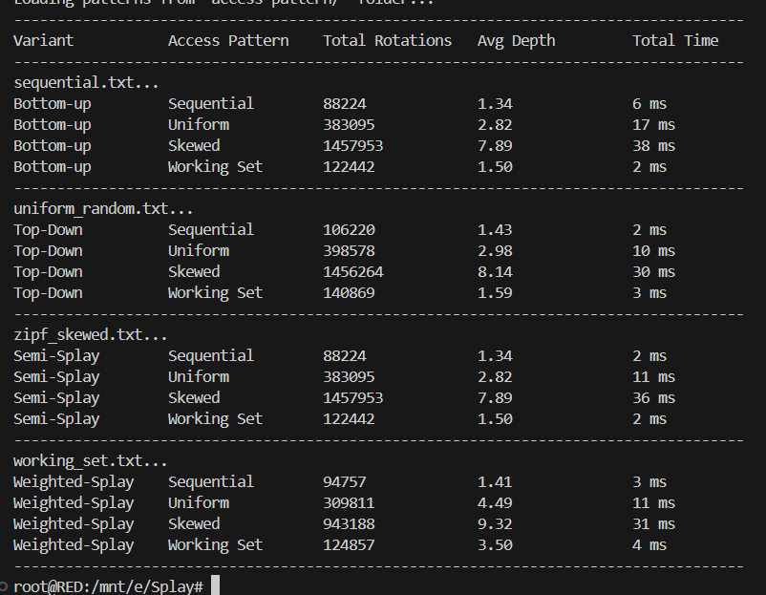

Task 5: Answer these questions briefly and clearly –
Is there an asymptotic bound difference in the complexity of the top-down and bottom-up implementations? What are the practical differences?
There is no asymptotic difference in time complexity between top-down and bottom-up splay tree implementations. Both has amortized time complexity of O(log n) per operation and have worst case time complexity of O(n).
The practical difference that can be seen is that Bottom-up splaying performs rotations after reaching the accessed node and then moves upward, which often requires maintaining parent pointers or recursion stacks. Top-down splaying performs restructuring while descending the tree, avoiding parent pointers and typically using fewer temporary references.
- Why is a splay tree not thread-safe?
It is not because every search insert or delete operation modifies the tree through rotation. In the case of multiple changes the simultaneous rotation may corrupt the pointer.

- What is the advantage of semi-splay and weighted-splay respectively.
Semi Splay reduces rotation overhead. Full splaying moves the accessed node all the way to the root everytime which can be expensive. Semi-splay limits how much restructuring happens, so the tree still improves over time but with less overhead. It’s basically a more balanced, “do just enough” approach.
Weighted Splay is adaptive behaviour based on access frequency. Nodes that are searched more often slowly move closer to the root because their weight increases, while rarely used nodes stay deeper in the tree. This makes the tree behave a bit like a cache, where frequently accessed items are quicker to reach.

- Explain your observations from Task 3 in a detailed write-up.
The tress started to reflect access patterns instead of insertion order. When certain keys were searched repeatedly, their weights increased and they naturally moved closer to the root over time. After a few searches, those nodes became much faster to access, and the tree stopped changing as aggressively. It also reduced unnecessary rotations. This made searches more predictable and avoided constant reshaping.

